- Write a C program where a parent process creates multiple child processes and synchronizes their completion using wait() and waitpid(). Compare the behavior of both functions
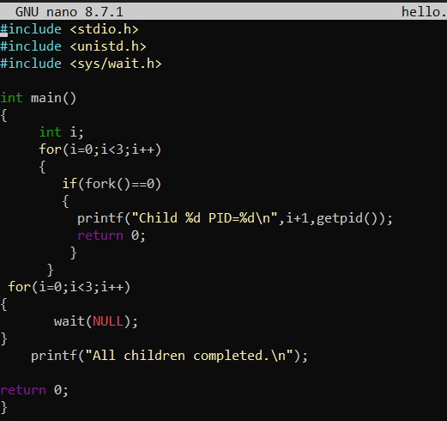

OUTPUT
